MUKILTEO LITTLE LEAGUE
2018 NEW BAT STANDARDS
FREQUENTLY ASKED QUESTIONS

New bat regulations go into effect January 1, 2018. Please familiarize yourself with the new bat standards to ensure any bats you purchase can be used for Mukilteo Little League play.

What is the new rule?

ALL baseball bats used for Rookie through Juniors baseball games and practices must have be USA Baseball Certified.

What does it mean to be USA Baseball Certified?

The certification is easy to identify. Look for the USA Baseball Logo on the neck of the bat just above the grip. Below is what the logo looks like:

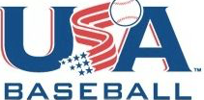

Who does the new rule affect?

Little League Baseball, Inc. has adopted the USA Baseball standards for baseball bats. This impacts Mukilteo Little League and all other Little Leagues throughout the country. If you are 14 years old or younger and play Little League, Babe Ruth, Cal Ripken, PONY, Dixie or AABC, you need to use a new bat marked with a new USA Baseball stamp.

The baseball divisions affected at Mukilteo Little League include Rookie, Farm, Minors, Majors, Intermediate, and Juniors. The regulations do not affect Tee Ball or Seniors play.

Is anyone not affected by the new rule?

USSSA youth baseball will not be making any rule changes to the bat regulations at this time. So if you are 14 years old or younger and you play on a travel or select ball team and are playing in a tournament that is under USSSA rules you can continue to use bats marked with the 1.15BPF stamp after January 1, 2018. For many Mukilteo Little League families this is not applicable, but for those that play select or tournament baseball, you do not have to sell or trade your recently purchased bats.

As noted above, Tee Ball and Seniors Little League divisions are not affected by the new bat rules.

What is the difference between the old and new bats?

Bats under the old standard generally show a marking on the barrel of the bat with a 1.15BPF stamp; these will no longer be allowed.

The look of the new bats will change. The goal is to make the bat play similar to a wood bat and it is expected that the new bats will lose approximately 10% of batted ball speed. The barrel size will increase to 2 5/8”, which will result in more contact with pitches. This is a change from the current standard of 2 1/4”. Under the new USA bat standard, both 2 1/4” and 2 5/8” barrel bats will be allowed for play.

One misconception is that new bats will not be made of composite materials. This is not true; you will see new bats made of composite, aluminum, and/or a combination of materials. The new bats will still have drop weight differences to allow youth players to swing a lighter bat without having to reduce the length.

The biggest change is that the new bats will have the USA Baseball stamp. This will show that the bat has been approved for use in Little League for 2018. Below is an example of a bat with the USA Baseball stamp:

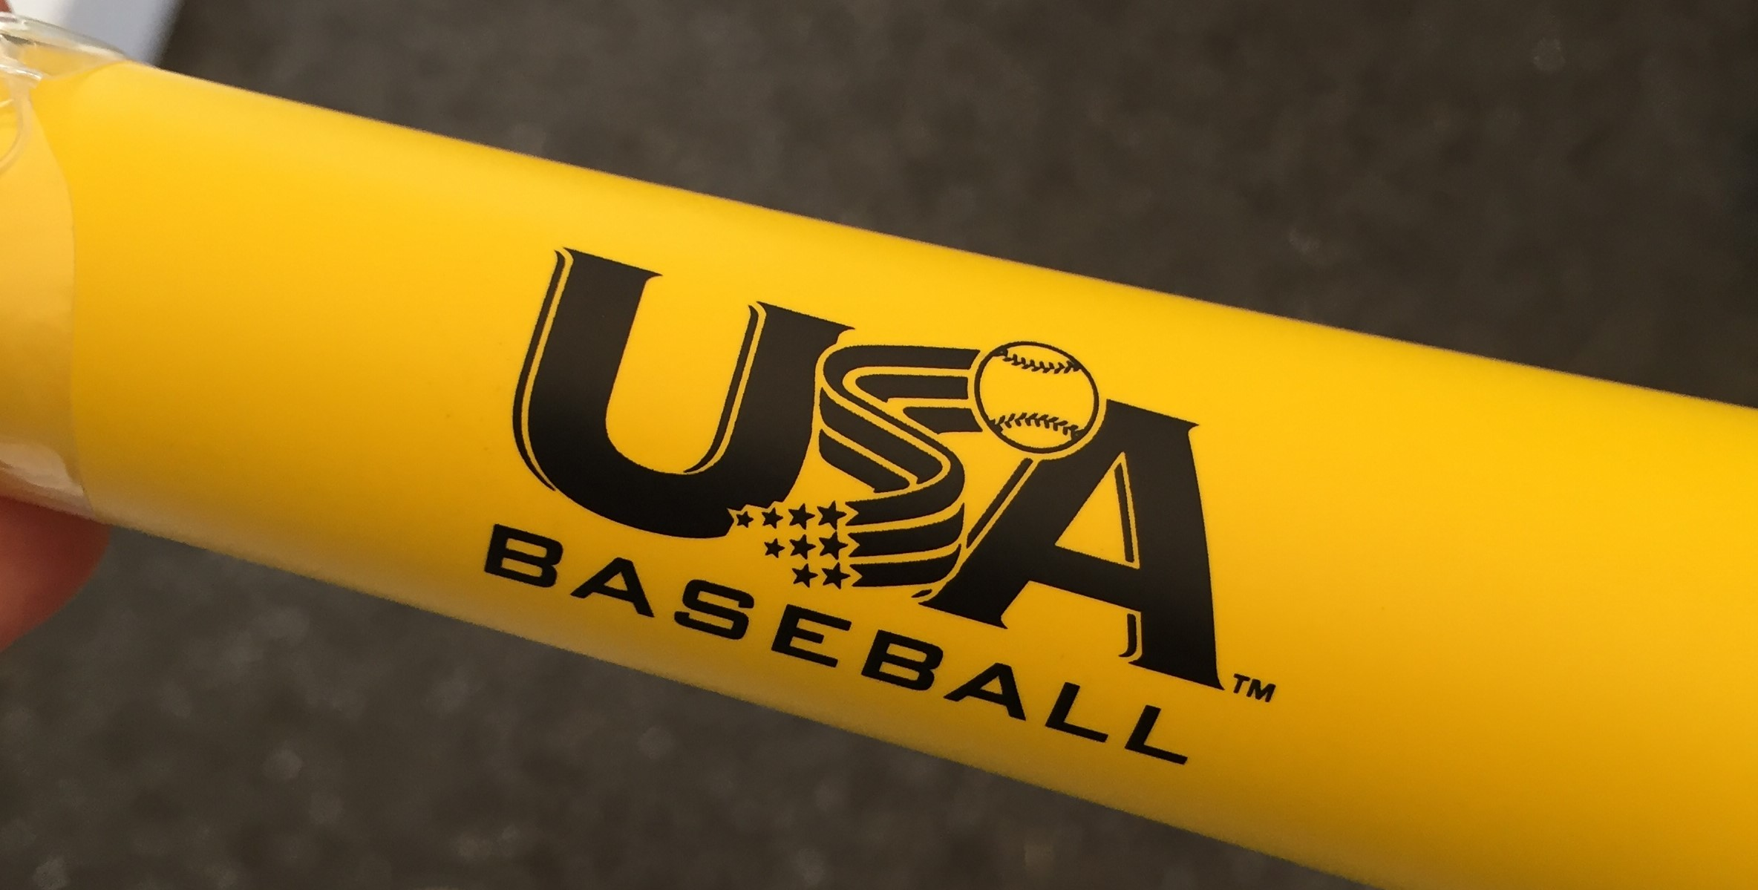

Are wood bats allowed instead of the new bats?

Mukilteo Little League allows the use of wood bats. Wood bats are allowed in our league and the use of a wood bat more commonly makes for a better hitter in the long term. Many players enjoy the use of composite or aluminum bats because they are constructed to take the “sting” out of a batted ball that is not struck by the barrel. For Rookie through Majors play, the only current regulations required for the use of a wood bat is that bat is no longer than 33” in length and it has a barrel size of 2 ¼” inches.

Are old bats grandfathered in?

No. There is no grandfathering of old bats at the Rookie through Juniors levels. All bats used for games and practices must be USA Baseball certified.

